**Steps**

1.ML model ( Open pickl file )

2. create a small UI(webpage)

3. python code to your file (flask)

4. process for deployment

a. access EC2

b. access WinSCP through PUTTY

c.

**FLASK**

* For mobile app development, flutter is used
* Python

**Program steps**

1. AWS🡪 EC2🡪Launch instance

Name : ec2-instance

1. AMI🡪Click ubuntu
2. Click - 22.04 LTS (free tier eligible)
3. 64 bit
4. Instance type – t3.micro (free tier eligible)
5. Key Pair
   1. Create key pair
      1. RSA (type)
      2. .ppk

Click download

1. Network settings
   1. Click check box all 3 (create)
   2. Click Edit
   3. Add security group rule
      1. Type – all traffic
      2. Source type – anywhere

All other same

Finally click 🡪 Launch instance

**Winscp configure steps**

Check the instance ece2🡪 click connect 🡪SSH client and copy details

Open Winscp 🡪 host name 🡪 DNS number (public DNS)

User name 🡪ubuntu

Password -- > click advanced 🡪 authentication 🡪 click the ec2file and click ok

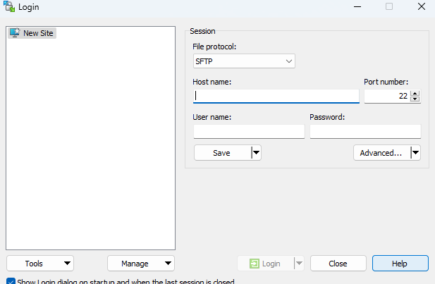

Click login -- > click accept

**ML files in Winscp**

You will 2 windows (left – windows, right- ubuntu)

Copy all files and paste in right window(ubuntu)

Click PUTYY from Winscp

Install pip command 🡪 sudo apt-get update && sudo apt-get install pip

**Now install flask**

>>Pip install flask

>>Pip install scikitlearn

>>Python3 app.py

**Now Run the webpage (dns:8080)**

**To remain webpage active even if putty closed.**

**>>**screen -R deploy python3 app.py

